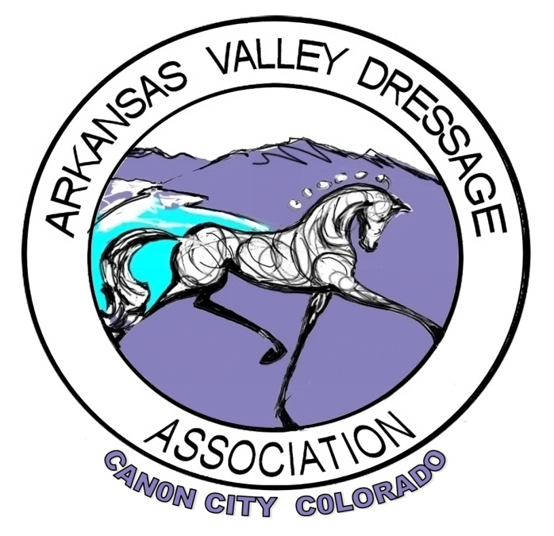
AVDA AWARDS POLICY
Revised 2023

General Requirements for Horse-Rider Of The Year
- Awards are based on a single horse-rider combination
- The rider MUST be a member of AVDA in good standing at the time the scores are achieved
- Volunteer Requirements must be met and are as follows
  - The rider must have contributed 4 hours of volunteer work at an AVDA sponsored event during the competition year to qualify for Year End Awards
  - The rider may designate a delegate to work for him/her
  - When a delegate works for another person, he/she must inform the show management/even organizer of the name of the member for whom he/she is working at the time the volunteer work is performed
  - A completed volunteer Hour Form must be submitted to the AVDA Volunteer Chair by November 1. This form can be found on the website at www.avdadressage.org
  - Volunteer hours can be earned as follows:
    - Attendance at any AVDA Board Meeting earns 1 volunteer hour
    - Volunteer at any RMDS or AVDA sponsored clinic, competition, or educational event with credit for actual hours worked
- All scored must be from a level that the judge is approved and rated to judge
    - Intro through Second – (L) and (r)
    - Intro through Fourth – ( R )
    - Intro through Grand Prix – (S)
- Scores from Hors de Concourse (HDC) rides will NOT count
- Schooling Shows will count
    - Scores from schooling shows may be used toward meeting the qualification requirements for AVDA Year End Awards
    - Scores earned at schooling shows will be accepted only if the judge is rated “L” or above (r, R, S)
    - For all schooling shows, the original tests or copies of the front of the test legibly showing the name of the judge, show, date and score must be submitted to the Awards Chair
    - Use 1 score submission form for each level and division application
    - The submission form is available on the AVDA website at www.avdadressage.org
- Score Submissions will NOT be accepted by phone- NO EXCEPTIONS. An online submissions form and downloaded documentation will be provided via the website
- Score Submissions may be mailed, emailed, submitted via the online google form or hand carried to the chairperson
- A horse-rider combination may only have scores in one division for each level
  - A single horse-rider combination may qualify for and earn awards at a maximum of 2 consecutive levels in a single year
- Scores MUST be earned during the current competition year
- The AVDA Awards Chairperson must receive ALL score submissions by November 5
- Perpetual trophies must be cleaned, polished and returned to the Awards chairperson no later than November 1 in order for the winner to be eligible for future awards
- Scores will not count if a rider competes in a dressage class before a judge by whom he/she or his/her horse has been instructed, coached, or tutored with or without pay within 30 days of the day of the competition
- The AVDA Award chair will calculate the initial results. A second AVDA member, typically the President or the President’s proxy will verify the results before they are made official
- Results will be on permanent record with AVDA
- The awards committee (chairperson and AVDA board members) reserve the rights to verify all submitted scores with show secretaries or RMDS

AVDA Year End Award Qualification Requirements

Award | Scores | Shows | Judges | RMDS Shows | Schooling Shows | Highest Test
Into – 4th | 3 | 2 | 2 | 0 | Yes | 1
Breed | 3 | 2 | 2 | 0 | Yes | 1
New To Dressage | 4 | 2 | 2 | 0 | Yes | N/A

AVDA will add new awards in the future. Consider donating a trophy!!

SPECIFIC REQUIREMENTS

INTRO – 4th
- 3 scores
- 2 shows
- 2 different judges or judge combinations
- 1 score MUST be from the highest test of the level
- The same horse-rider combination may not win the first place award more than once at the same level and division

FREESTYLE
- 2 scores
- 2 shows
- 2 different judges or judge combinations
- 1 score must be from an RMDS or higher recognized show
- Award presented for 1st place only

BREED
- 3 scores
- 2 shows
- 2 different judges or judge combinations
- 1 score from the highest test of the level
- All riders must be from the same level and division
- Horse must be registered with appropriate breed organization (except grade horses)
- A copy of registration papers must be submitted to AVDA (except grade horses)
- Award presented for 1st place only
- AVDA currently has awards for the following breeds:
    - American Quarter Horse
    - Arabian
    - Draft
    - Friesian
    - Grade
    - Holsteiner
    - Paint Horse
    - Pony
    - Trakehner
- Other breeds will be awarded if applications are received, and a trophy exists or a new trophy is provided
- Trophy Donations Are Always Welcome

NEW TO DRESSAGE
- 4 scores
- 2 shows
- 2 different judges or judge combinations
- All scores will be averaged
- Any test of the level
- Awarded to a rider in his/her first year of competition in dressage
- Limited to Intro and/or Training levels with only 1 award given
- Closed to OPEN designated riders, available only to JR/YR and AA riders
- Separate awards will be given for JR/YR and AA
- All scores can be from schooling shows where the judge is rated (L) or above

NON RIDING AWARDS:
All nominations for these awards must be made in writing by an AVDA member and include a justification for the nomination. Candidates must be a member of AVDA. The nomination form is available on the website at www.avdadressage.org or by contacting the AVDA Awards Chair.
  - Volunteer of The Year: for the member who gives his/her time and talent to the club

MORE TO COME IN THE FOLLOWING YEARS!!!

