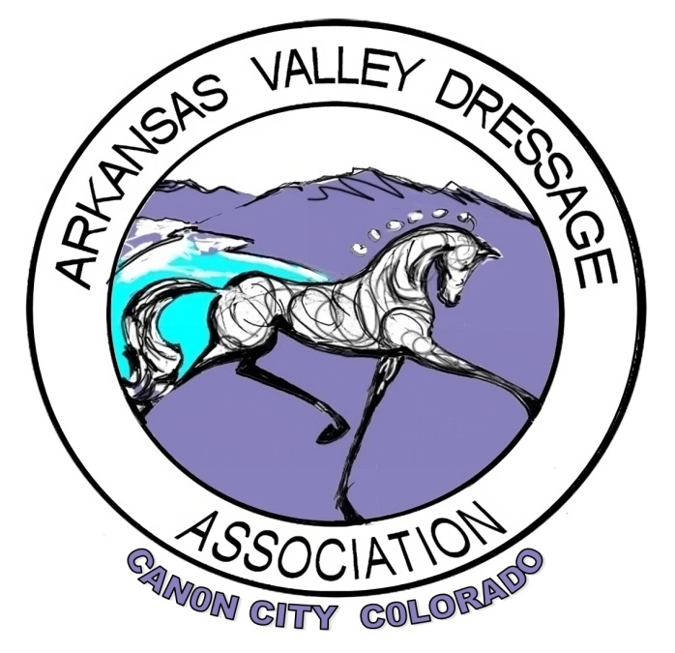
ARKANSAS VALLEY DRESSAGE ASSOCIATION
SOCIAL MEDIA POLICY

Arkansas Valley Dressage Association (“AVDA”) will use social media to promote its mission, grow its base of support, educate, improve communication, engage members, and demonstrate leadership, and increase membership and participation. The president will delegate responsibility for the AVDA website and social media. There will be two administrative authorities, the president, (or the president’s representative), and the delegated member(s), to guide the website, Face Book, and any other social media AVDA sites. Before being posted, the AVDA board must approve any content that represents the collective interest or opinion of AVDA.

AVDA will include information regarding AVDA and /or events and activities that are open to all of its members. Fake profiles or unauthorized marketing will be blocked or deleted. No discriminatory, inflammatory, derogatory, accusatory, or hate speech or criticism of any kind will be allowed, even in the slightest context. Such language (posts) will be immediately deleted at the discretion and direction of no less than three (3) members of the Executive Board of Directors. The Executive Board of Directors reserves the right to delete any or all posts on the AVDA Face Book page, no matter what the content, by a vote of no less than three (3) members of the Executive Board of Directors.

Topics will include:

- All volunteer opportunities that serve to fulfill AVDA and RMDS Award requirements
- Information about shows and clinics
- Reviews, positive raves and photos of past clinics and shows
- Educational articles about dressage
- Articles written by members
- Volunteer of the month and volunteer achievements
- Posts that encourage participation

To improve social media efforts, AVDA will:

- Post frequently using relevant information, so that more users will rely on AVDA as “the place to go” for information regarding dressage in the region. Additional posting will increase visability (thanks to Social Media algorithms).
- Continue to seek AVDA members who are interested in social media, writing, photography, promotion, and marketing to support this effort.
- Closely monitor AVDA social media sites and ensure all incoming posts/comments are appropriately responded to.

Social Media Posts Will:

- Be professional but welcoming.
- Encourage participation and a sense of inclusion.
- Include a relevant photo.
- Link back to the AVDA website.
- Be brief, concise and to the point.
- Be reviewed before posting. All individual posts must be reviewed and approved by the Face -Book Administrator before being posted
- Comments are allowed on existing posts, providing they adhere to the AVDA Social Media Policy
- Not promote specific businesses.
- Focus on educational pieces featuring classical dressage.
- Use disclaimers, as needed: “Views expressed are my own”.
- Uphold AVDA values and policies.
- Respect the confidentiality and privacy of members.
- Target all members: Youth, Seniors, Armatures, and Professionals

Penalty for non-compliance:

- First offence: Individuals breaking the AVDA Social media Policy will be given a warning, through a communication method of Executive Board of Directors’ choice, from the Executive Board of Directors to the offending individual.
- Second offence: Individual breaking the AVDA Social Media Policy will be blocked from the AVDA Face Book page, as per Executive Board of Directors majority decision.

Up dated 2024

